

A Minor Project Report on

**IMPLEMENTATION OF WIRELESS CHARGING SYSTEM FOR ELECTRIC VEHICLE**



**ABIRAMI S (20BEE4002)**

**MONIKA P (20BEE4049)**

**NANDHA KUMAR M (20BEE4054)**

**DEPARTMENT OF ELECTRICAL AND ELECTRONICS**

**ENGINEERING**

**M.KUMARASAMY COLLEGE OF ENGINEERING**

**(An Autonomous Institution - Affiliated to Anna University, Chennai)**

**Karur - 639 113**

**December 2022**

## i

## M.KUMARASAMY COLLEGE OfENGINEERING

(Autonomous Institution ,Affiliated to AnnaUniversity, Chennai)

## BONAFIDE CERTIFICATE

Certified that this Report titled“**IMPLEMENTATION OF WIRELESS CHARGINGSYSTEM FOR ELECTRIC VEHICLE**” is the bonafidework **ABIRAMI S (20BEE4002),MONIKA P (20BEE4049),NANDHA KUMAR M (20BEE4054)**, who carried out the work during the academic year (2022-2023).

## SUPERVISOR HEAD OF THE DEPARTMENT

Dr.S.Sathish Kumar.M.E.,Ph.D., Dr.C.Kumar.M.E.,Ph.D.,

Associate Professor Professor and Head

Department of Electrical and Electronics Engineering Department of Electrical and ElectronicsEngineering

M.Kumarasamy College of Engineering, M.Kumarasamy College of Engineering, Karur. Karur.

Submitted for Minor Project III (18EEP301L) viva-voce Examination held on __________________.

**ii**

## DECLARATION

We affirm that the Minor Project report titled “**IMPLEMENTATION OF WIRELESS CHARGING SYSTEM FOR ELECTRIC VEHICLE**”being submitted in partial fulfillment for the award of **Bachelor of Engineering in Electrical and Electronics Engineering** , is the original work carried out by us.

|  |  |  |
| --- | --- | --- |
| **REG.NO** | **STUDENT NAME** | **SIGNATURE** |
| **20BEE4002** | **ABIRAMI S** | **______________** |
| **20BEE4049** | **MONIKA P** | ______________ |
| **20BEE4054** | **NANDHA KUMAR M** | **______________** |

**iii**

## VISION AND MISSION OF THE INSTITUTION

**VISION**

* To emerge as a leader among the top institutions in the field of technicaleducation

## MISSION

* Produce smart technocrats with empirical knowledge who can surmount the global Challenges.
* Create a diverse, fully-engaged, learner - centric campus environment to provide Quality education to thestudents.
* Maintain mutually beneficial partnerships with our alumni, industry and Professional associations.

**DEPARTMENT OF ELECTRICAL AND ELECTRONICS ENGINEERING**

**VISION**

To produce smart and dynamic professionals with profound theoretical and practical knowledge comparable with the best in thefield.

## MISSION

* Produce hi-tech professionals in the field of Electrical and Electronics Engineering by inculcating core knowledge.
* Produce highly competent professionals with thrust onresearch.
* Provide personalized training to the students for enriching theirskills.

## PROGRAMME EDUCATIONAL OBJECTIVES(PEOs)

## In minor project report update the following as Program Educational Objectives (PEOs)

## PEO1: Graduates will have flourishing career in the core areas of Electrical Engineering and allied disciplines.

## iv

## PEO2: Graduates will pursue higher studies and succeed in academic/research careers.

## PEO3: Graduates will be a successful entrepreneur in creating jobs related to Electrical and Electronics Engineering /allied disciplines.

## PEO4: Graduates will practice ethics and have habit of continuous learning for their success in the chosen career.

## PROGRAMME OUTCOMES(POs)

After the successful completion of the B.E. Electrical and Electronics Engineering degree program,the students will be able to:

**PO1: Engineering Knowledge:** Apply the knowledge of mathematics, science, engineering fundamentals, and an engineering specialization to the solution of complex engineering problems.

**PO2: Problem Analysis:**Identify,formulate,review research literature,and analyze complex engineering problems reaching substantiated conclusions using first principles of mathematics, natural sciences,and engineering sciences.

**PO3: Design/Development of solutions:**

Design solutions for Complex engineering problems and design system components or processes that meet the specified needs with appropriate consideration for the public health and safety,and the cultural, societal and environmental considerations.

**PO4: Conduct Investigations of complex problems:** Use research-based knowledge and research methods including design of experiments,analysis and interpretation of data, and synthesis of the information to providevalidconclusions.

**v**

**PO5:Modern Tool Usage:**Create,select,and apply appropriate techniques,resources,and modern engineering and IT tools including prediction and modeling to complex engineering activities with an understanding of the limitations.

**PO6:The Engineer and Society:**Apply reasoning in formed by thecontextual knowledge to assess societal,health,safety,legal and cultural issues and the consequent responsibilities relevant to the professional engineering practice.

**PO7:Environment and Sustainability:**Understand the impact of the professional engineering solutions in societal and environmental contexts,and demonstrate the knowledge of, and need for sustainable development.

**PO8: Ethics:** Apply ethical principles and commit to professional ethics and responsibilities and norms of the engineering practice.

**PO9: Individual and Team work:**Function effectively as an individual,and as a member or leader in diverse teams,and in multi-disciplinarysettings.

**PO10:Communication:**Communicate effectively on complex engineering activities with the engineering community and with society at large,such as,being able to comprehend and write effective reports and design documentation, make effective presentations,and give and receive clear instructions.

**PO11: Project Management and Finance:** Demonstrate knowledge and understanding of the engineering and management principles and apply these to one’s own work,as a member and leader in a team,to manage projects and in multi-disciplinary environments.

**vi**

**PO12:Life-long learning:**Recognize the need for,and have the preparation and ability to engage in independent and life-long learning in the broadest context of

technological knowledge.

**PROGRAM SPECIFIC OUTCOMES(PSOs)**

The following are the Program SpecificOutcomes of Engineering Students:

**PEO1:** Graduates will have flourishing career in the core areas of Electrical Engineering and allied disciplines.

**PSO2:** Graduates will pursue higher studies and succeed in academic/research careers.

**PSO3:** Graduates will be a successful entrepreneur in creating jobs related to Electrical and Electronics Engineering /allied disciplines.

**PSO4:** Graduates will practice ethics and have habit of continuous learning for their success in the chosen career.

|  |  |
| --- | --- |
| **Abstract (Key Words)** | **Mapping of POs and PEOs** |
| Electric Vehicle, Energy Storage System, Plug-in Electric Vehicles | PO1,PO2,PO3,PO4,PO5,PO6,PO7,PO8,PO9, PO10,PO11,PO12,PSO1,PSO2,PSO3, PSO4. |

**vii**

## ACKNOWLEDGEMENT

Our sincere thanks to **Thiru.M.Kumarasamy,** Chairman and **Dr.K.Ramakrishnan, B.E, Secretary of M.Kumarasamy College of Engineering** for providing extraordinary infrastructure,which helped us to complete the Minor project in time.

It is a great privilege for us to express our gratitude to our esteemed Principal **Dr.N.RameshBabu M.E.,Ph.D.,**for providing us right ambiance for carrying out the project work.

We would like to thank our **Head of the Department Dr.C.Kumar, M.E.,Ph.D.,Department of Electrical and Electronics Engineering**,for his unwavering moral support throughout the evolution of theproject.

We offer our wholehearted thanks to our Minor project coordinator **Mr.M.RameshM.E., Assistant Professor**,**Department of Electrical and Electronics Engineering,**for his constant encouragement, kind co-operation and valuable suggestions for making our project a success.

We would like to express my deep gratitude to our Minor Project Guide **Dr.S.Sathish Kumar M.E.,Ph.D., Associate Professor, Department of Electrical and Electronics Engineering**,for his constant encouragement,kind co-operation,valuable suggestions and support rendered in making our project a success.

We glad to thank all the **Faculty Members of Department of Electrical and Electronics Engineering** for extending a warm helping hand and valuable suggestions throughout the project.

Words are boundless to thank Our Parents and Friends for their constant encouragement to complete this Minor project successfully.

**viii**

# TABLEOFCONTENTS

|  |  |  |
| --- | --- | --- |
| **Chapter No** | **Contents Page No** |  |
|  | **ABSTRACT**x |  |
|  | **LISTOF TABLES**xi |  |
|  | **LISTOF FIGURES**xii |  |
|  | **LISTOFABBREVATIONS**xiii |  |
| **1** | **INTRODUCTION** 1 |  |
|  | 1.1Introduction 1 |  |
|  | 1.2Necessity1 |  |
|  | 1.3Scopeofthework 2 |  |
| **2** | **SYSTEM MODEL**3 |  |
|  | 2.1Introduction 3 |  |
|  | 2.2BlockDiagram 3 |  |
|  | 2.3Descriptionofvariousblocks4 |  |
| **3** | **HARDWAREDESCRIPTION** 6 |  |
|  | 3.1Introduction 6 |  |
|  | 3.2Circuitdiagram7 |  |
|  | 3.3Hardwarecomponents 8 |  |
| **4** | **RESULTANDDISCUSSION**9 |  |
|  | 4.1HardwareImplementation 9 |  |
|  | 4.2WorkingoftheProjectmodel 10 |  |
| **5** | **CONCLUSIONANDFUTURESCOPE**13 |  |
|  | 5.1Conclusion 13 |  |
|  | 5.2FutureScope 13 |  |
|  | 5.3Merits &Demerits 14 |  |
|  | **REFERENCES** 15 |  |

**ix**

**ABSTRACT**

Electric vehicles are seen as an alternative option in response to the depletion of resources. In order to increase the use of EVs in daily life, practical and reliablemethods to charge batteries of EVs are quite important, accordingly wireless power transfer (WPT) is considered as a solution to charge batteries. In this project, a prototype system of wireless charger which has 60 kHz operation frequency is designed and implemented. Plug-in Electric Vehicles (PEV) are burdened by the need for cable and plug charger, galvanic isolation of the on-board electronics, bulk and cost of this charger and the large energy storage system (ESS) packs needed. But by using Wireless Charging system‘s Wireless charging opportunity. It Provides convenience to the customer, inherent electrical isolation, regulation done on grid side and reduce on-board ESS size using dynamic on-road charging. The main objective of our project is to design and develop antenna system suitable for vehicle using resonant magnetic coupled wireless power transfer technology to electric vehicle charging system. Application of WPT in EVs provides a clean, convenient and safe operation. At the core of the WPT systems are primary and secondary coils. These coils construct a loosely coupled system where the coupling coefficient is between 0.1-0.5. In order to transfer the rated power, both sides have to be tuned by resonant capacitors. The operating frequency is a key selection criterion for all applications and it especially affects the dimensions of the coils and the selection of the components for the power electronic circuit. A Resonant wireless transfer system for vehicle charging technology is designed.

**x**

# LISTOFTABLES

|  |  |  |
| --- | --- | --- |
| **Table No** | **Title** | **PageNo** |
| 3.1 | HardwareComponentsanditscost | 8 |

**xi**

**LIST OF FIGURES**

|  |  |  |
| --- | --- | --- |
| **Figure No** | **Figure Name** | **Page No** |
| 2.1 | Block diagram of the system | 3 |
| 3.1 | Circuit diagram of the system | 6 |
| 4.1 | Experimental Setup | 8 |

# xii

# LIST OFABBREVIATION

|  |  |  |
| --- | --- | --- |
| **S No** | **ABBREVIATION** | **EXPANSION** |
| 1 | WPT | Wireless Power Transfer |
| 2 | EV | Electric Vehicle |
| 3 | SMPS | Switched Mode Power Supply |

# xiii

**CHAPTER 1**

**INTRODUCTION**

# Introduction

During the last few decades, increased concern over the environmental impact of the petroleum-based transportation infrastructure, along with the specter of peak oil, has led to renewed interest in an electric transportation infrastructure. Battery-powered electric vehicles (EVs) seem like an ideal solution to deal with the energy crisis and global warming since they have zero oil consumption and zero emission. Moreover, we are quite rapidly reaching the end of the cheap oil era. Therefore, the need for alternative growing and the price competition of alternatives against oil is becoming more and more realistic.Electric vehicles differ from fossil fuel-powered vehicles in that the electricity they consume can be generated from a wide range of sources, including fossil fuels, nuclear power, and renewable sources such as tidal power, solar power, and wind power or any combination of those. However it is generated, this energy is then transmitted to the vehicle through use of overhead lines, wireless energy transfer such as inductive charging, or a direct connection through an electrical cable. The electricity may then be stored onboard the vehicle using a battery, flywheel, or super-capacitors. Vehicles making use of engines working on the principle of combustion can usually only derive their energy from a single or a few sources, usually non-renewable fossil fuels. A key advantage of electric or hybrid electric vehicles is regenerative braking and suspension, their ability to recover energy normally lost during braking as electricity to be restored to the on-board battery. However, EVs are highly depended on the external energy support.

# 1.2Necessity

The use of EVs’ among people is reaching a new records but the only issue with EVs’ are charging batteries. Charging batteries with cables usually have problems like tripping hazards, waiting at charging stations for long time, risk of damaged cables.

**1**

# 1.3Scopeofthework

Wireless power has a bright future in providing wireless electricity. There are no limitations in power applications. Some of the potential applications are powering of cell phones, laptops and other devices that normally run with the help of batteries or plugging in wires. Wireless power applications are expected to work on the gadgets that are in close proximity to a source of wireless 'power, where in the gadgets charges automatically without necessarily, having to get plugged in. By the use of Wireless power there is no need of batteries or remembering to recharge batteries periodically. If a source is placed in each room to provide power supply to the whole house.Wireless power has many medical applications. It is used for providing electric power in many commercially available medical implantable devices. Another application of this technology includes transmission of information. It would not interfere with radio waves and it is cheap and efficient.

**2**

# CHAPTER2

**SYSTEMMODEL**

# 2.1Introduction

The main objective of our project is to design and develop antenna system suitable for vehicle using resonant magnetic coupled Wireless Power Transfer(WPT) technology to electric vehicle charging system. Application of WPT in EVs provides a clean, convenient and safe operation. At the core of the WPT systems are primary and secondary coils. These coils construct a loosely coupled system where the coupling coefficient is between 0.1-0.5.

**2.2 BlockDiagram**

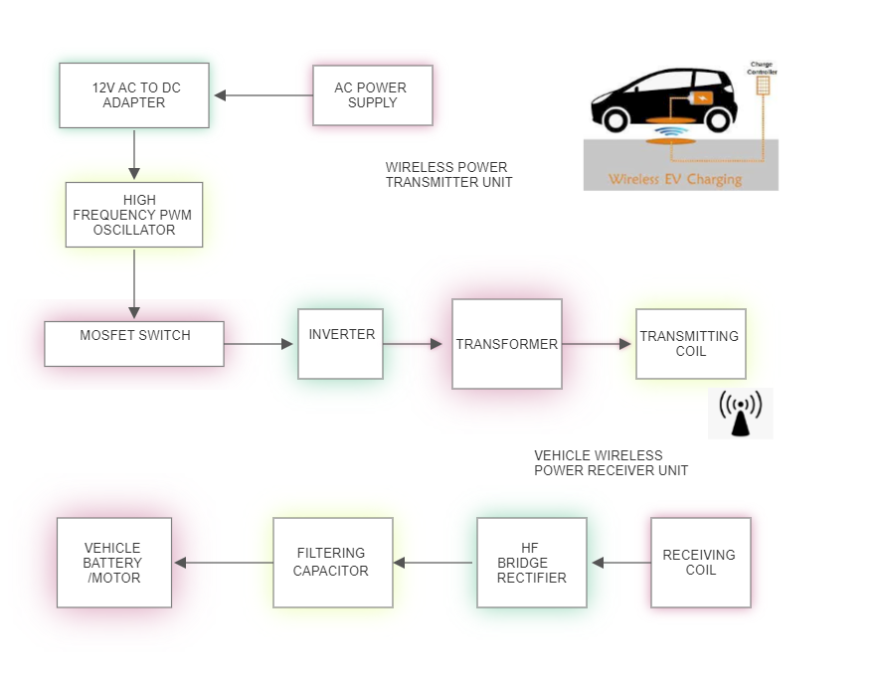

**Figure 2.1Blockdiagramof thesystem**

**3**

**2.3Descriptionofvarious blocks**

**AC Power Supply**

The supply for the wireless power transmitter is taken from AC220v source.

**AC-DC Adapter (SMPS)**

Switching Mode power supply is used here to convert AC to DC. Here the input of the SMPS is 220v AC and output will be 12v DC.

**High Frequency PWM Oscillator**

High Frequency oscillator is designed using KA3525 IC. The IC circuit generates PWM switching pulses for driving the MOSFETs. The oscillator produces a PWM frequency of 65 KHz range. Here two separate PWM pulses PWM1 and PWM2 are produced which are supplied to the two MOSFET gate. Each PWM pulses are 90 degrees out of phase, which result in alternative switching of each MOSFETs.

**Driver MOSFETs**

Here two driver MOSFETs are used to switch the high frequency transformer. The two ends of the transformer primary is connected to the ‘Drain’ pin of the two MOSFETs. When a MOSFET gets turned ON, then current flows through the primary winding of the transformer. Half of the primary gets turned ON by one MOSFET and another half by another MOSFET. Both MOSFETs switch alternatively producing a AC square wave in the primary of the transformer.

**High Frequency Transformer**

Here the DC-AC conversion takes place in the high-frequency switching transformer. Unlike normal transformer, the core of the HF transformer is made of ferrite which makes it capable of operating at higher frequencies. Due to high frequency switching the losses in conversion is very lower than normal transformer. Here the HF transformer converts DC current into a high-frequency AC current. The primary of transformer has three tappings, one is centre tap for DC current input and other two tapings for return path of the current through MOSFETs during switching. The secondary output will be HF AC current, which is given to the transmitter coil.

**4**

**Half bridge Inverter**

Half bridge inverter circuit driver consists of a high-frequency switching transformer and two MOSFETs. The switching transformer primary is connected to two MOSFETs and secondary is connected to transmitting coil. The half bridge inverter converts input DC voltage into a high frequency AC voltage.

**Transmitting Coil**

The transmitter coil is designed with windings of copper coils which convert the high frequency oscillating electrical current into electromagnetic waves resonating at a particular frequency.

**Receiving Coil**

The receiver coil receives electromagnetic waves from the transmitter antenna and converts back into high frequency electrical output.

**HF Bridge Rectifier**

High Frequency (HF) bridge rectifier consists of fast switching rectifier diodes which converts HF AC voltage from the receiving coil into a DC voltage.

**Filtering Capacitor**

The filtering capacitor filters out the ripple generated at the rectifier and produces as smooth and stable DC voltage output which can be used for driving the vehicle motor or for battery charging purpose.

**5**

**CHAPTER 3**

# HARDWAREDESCRIPTION

# 3.1Introduction

In an effort to address battery problems, the concept of roadway-powered electric vehicles has been proposed. With this system, the electric vehicle is charged on the road by wireless power charging, and the battery can hence be downsized and no waiting time for charging is needed. The main objective of our project is to design and develop antenna and wireless power transfer system suitable for moving electric vehicles (EVs). Using resonant magnetic coupling principle, the wireless power transfer technology to the electric vehicle is designed. When the vehicle’s power receiver’s frequency is tuned in exact with the resonance frequency of the transmitter unit below the road, the electrical power will flow from the transmitter coil inside the platform to the receiving coil inside the bottom of the electric vehicle. This project describes the design and implementation of a wireless power transfer system for moving electric vehicles involving the model EV system. Wireless power transfer (WPT) is a breakthrough technology that provides energy to communication devices without the power units. With the remarkable progress being made recently, this technology has been attracting a lot of attention of scientists and R&D firms around the world. Recently, the usage of mobile appliances such as cell phones, PDAs, laptops, tablets, and other handheld gadgets, equipped with rechargeable batteries has been widely spreading. It is known that electromagnetic energy is associated with the propagation of electromagnetic waves. Theoretically, we can use all electromagnetic waves for a wireless power transmission (WPT).

# 6

# 3.2 Circuitdiagram

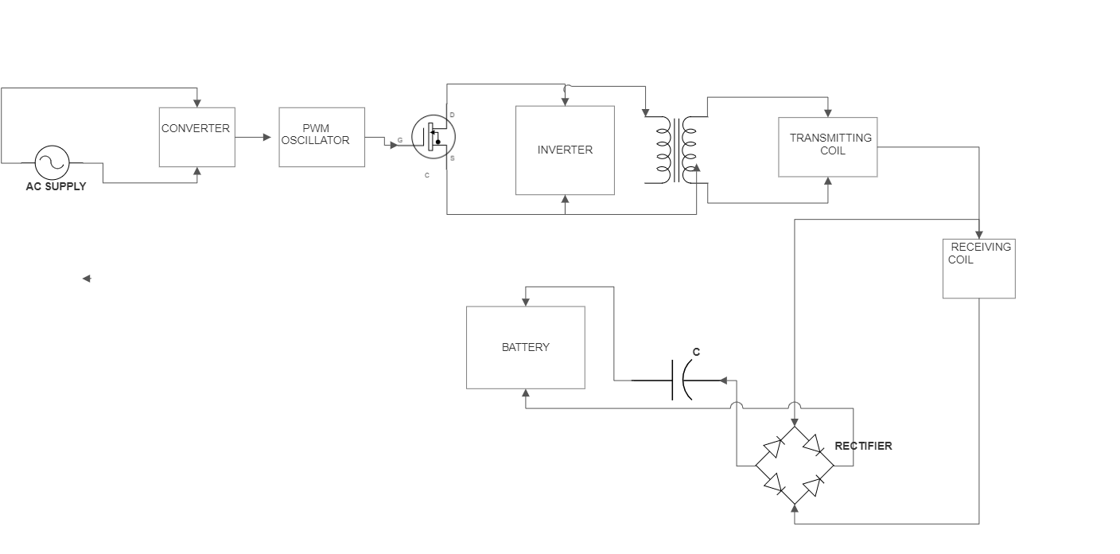

**Figure3.1 Circuit diagram ofthesystem**

**7**

# 3.3HardwareComponents

|  |  |  |  |
| --- | --- | --- | --- |
| **S.No** | **ComponentsUsed** | **Quantity** | **Costin Rs.** |
| 1 | Toy car | 1 | 210 |
| 2 | Transformer | 1 | 560 |
| 3 | Ac Adapter | 1 | 320 |
| 4 | Transmitter coil | 1 | 480 |
| 5 | Receiver Coil | 1 | 480 |
| 6 | Cardboard | 1 | 20 |

**TOTAL= 2070**

# Table3.3HardwareComponentsanditsCost

# 8

**CHAPTER4**

**RESULTANDDISCUSSION**

* 1. **HardwareImplementation**

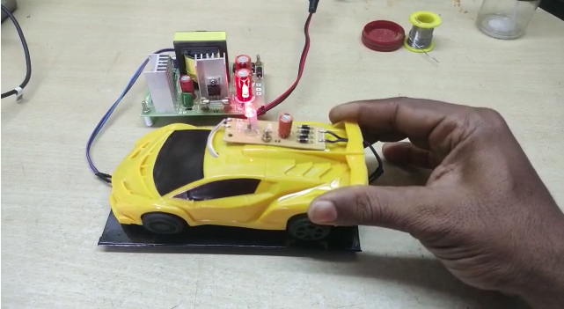

**Figure4.1 ExperimentalSetup**

**9**

# 4.2WorkingofProjectmodel

**Transmitter Section**

1.The first section of the circuit is the High-Frequency inverter which is designed using SG3525 IC. It produces High Frequency PWM signal. The frequency range is 60 – 75 KHz.

2.The second section is the Half-Bridge Driver circuit which consists of two N-channel MOSFETs. MOSFETs drivers feed the PWM signal to the primary of a HF switching transformer.

3.The third section is the High-Frequency Transformer. It converts the DC DC input fed in the primary coil by the MOSFETS into HF AC output at its secondary coil.

4.The fourth section is the transmitting coil. It converts the fed HF-AC current into electromagnetic waves.

SG3525 IC is basically a PWM oscillator chip which produces high-frequency PWM signal which can drive MOSFETs directly to switch then ON and OFF. The frequency of the PWM signal can be set and also adjusted using the timing control resistor and capacitor which are connected to the pin-6 and pin-5 (RT and CT). The IC has two PWM outputs which are pin-11 and pin-14 (out A and out B). Two pwm outputs are connected to the gate terminal of MOSFETs connected in half-bridge configuration. Transmitter coil is a centre tapped coil, so it has three terminals.

The Drain terminal of the two MOSFETs are connected to two ends of the transmitter coil. Centre tap of the coil is connected to the DC source power supply which is 12v.

**10**

When power is turned ON the IC SG3525 starts oscillating and produces PWM signals. The MOSFETs connected to its outputs are switched ON and OFF alternatively. The Out A and Out B of the IC output are 90degrees out of phase. So when one MOSFET is in ON condition the other will be in OFF condition. Here we use a oscillator frequency of 60 to 80KHz frequency range. So the MOSFETs are switched at high frequency.

When on MOSFET is in ON condition the DC current will flow from the centre tap of transmitter coil through MOSFET drain terminal and reach the source terminal which is connected to ground. So in first half cycle the direction of DC current will be in first half coil portion of thetransmitter coil. In the same way the current flow will be in second half portion of the coil during next half cycle. Thus the two MOSFETs create a current flow which are opposite in direction in each switching cycle. So as a result an alternating current is produced in the transmitting coil. This configuration thus produces a high frequency AC current from the input DC current. Transmitter coil converts the HF AC electric current into HF electromagnetic field. Thus the transmitter coil coverts electric current and transmits in the form of electromagnetic waves.

**Receiver Section**

Receiver has a three section.

1.First is the receiver coil

2.Second is the High-Frequency rectifier

3.Third is the DC ripple filter

Receiver has a receiving coil which has same resonant frequency of the transmitter coil. So when placed near the transmitter coil it will pick up the electromagnetic field and converts it into the high frequency AC current. Output of receiver coil is given to a high frequency rectifier which converts HF AC to DC voltage output. A capacitor filter at the output of rectifier filters the ripple in DC and gives a stable DC output voltage. A DC output is produced at the output of receiver which is used to power any DC loads.

**11**

The electrical power flows from the power transmitter coil inside the platform to the receiving coil inside the bottom of the electric vehicle. Electrical charging is done once the resonant frequency of both the coils matches and the vehicle charged automatically. When the vehicle is moved the charger goes to the power saving mode and cut off the charger coil.

A wireless power transfer system uses inductive coupling. One of the most important factors that must be considered in designing an inductive coupling system is the target power of the system. Voltage and current ranges, usable devices, and operating frequency of the system depend on the target power. Because the wireless power transfer system for moving electric vehicles is a public service system that is installed in a road, the use of the resonance frequency must be permitted by the government.

# 12

# CHAPTER5

**CONCLUSIONANDFUTURESCOPE**

# Conclusion

In this project we have introduced a controller that can be used in Wireless EV charging systems to charge electric vehicles without wires. The proposed controller is capable of self-tuning the switching operations of the converter to the resonance frequency of the WPT system, and therefore eliminates the need for switching frequency tuning. Also, it enables soft-switching operations in the converter, which will result in a significant increase in the efficiency of the power electronic converter.Contactless electric vehicle (EV) charging based on inductive power transfer (IPT) systems is a new technology that brings more convenience and safety to the use of EVs.Since it eliminates the electrical contacts, it would not get affected by rain, snow, dust and dirt, it is a safe, reliable, robust and clean way of charging electric vehicles, reduces the risk of electric shock.

* 1. **FutureScope**

Dynamic wireless charging systems can be installed on the roads so that the Electric Vehicles can be charged while in motion. Also, a charge monitoring system can be developed for the authorised owner to get the notification about the status of the battery of the vehicle.Mathematical Modelling of ‘Bulk Service Queue Model’ have been developed to reduce the queue waiting at the charging station.

# 13

# 5.3Merits & Demerits

# Merits

1. No need of line of sight - In Wireless powertransmission there is any need of line of sight between transmitter and receiver. That is power transmission can be possible if there is any obstructions like wood,metal, or other devices were placed in between the transmitter andreceiver.
2. No need of power cables and batteries - Wireless power replaces the use of power cables and batteries.
3. Does not interfere with radio waves
4. Negative health implications - By the use of resonant coupling wavelengths produced are far lower and thus make it harmless.
5. Highly efficient than electromagnetic induction - Electromagnetic induction system can be used for wireless energy transfer only if the primary and secondary are in very close proximity. Resonant induction system is one million times as efficient as electromagnetic induction system.
6. Less costly - The components of transmitter and receivers are cheaper. So this system is less costly.

**Demerits**

1. Wireless power transmission can be possible only in few meters.
2. Efficiency is only about 40% for long distances and near 85% for short distances.
3. As Wireless power is in development stage, lot of work is done for improving the efficiency and distance between transmitter and receiver.

**14**

# REFERENCES

1.Telsa, N.; Marincic, A. S., " Nikola Tesla and the wireless transmission of energy," IEEE Trans. Power App. Syst., vol. PAS-101, no. 10, pp. 4064–4068, Oct.2018.

2.Hui, S. Y., " Planar wireless charging technology for portable electronic products and Qi.," IEEE Trans. Power App. Syst., vol.101, no. 6, pp. 1290–1301, June 2020.

3.Ahn, D.; Hong, S., " Wireless power transmission with self-regulated output voltage for biomedical implant," IEEE Trans. Ind. Electron, vol.61, no. 5, pp. 2225–2235, May 2019.

4. IHI Corporation, "Making electric vehicles easier to use,"www.ihi.co.jp/en, vol. 46, no. 1, 2018.

5.Lu, X.; Niyato, D.; Wang, P.; Kim D.I., "Wireless charger networking for mobile devices: fundamentals, standards, and applications", IEEE Wireless Communications, 2018.

6.Kurs, A.; Karalis, A.; Moffatt, R.; Joannopoulos, D.; Fisher, P.; Soljacic, M., "Wireless Power Transfer via Strongly Coupled Magnetic Resonances, " Science, vol. 317, no. 5834, pp. 83- 86, Jul. 2019.

7.Habib, S.; Haque, A., “Impulsive noise mitigation in wireless communication systems using EMD technique”. In 2018 7th International Conference on Electrical and Computer Engineering, pp. 291-294, December 2020

**15**